Submitted by Group 2

Submission Date: 8 Sep 2025
Risk Identification Report
Table of Contents

Pampered Pets Risk Identification Report 3
1.1. Introduction 3
1.2. Background and Context 3
1.3. Risk Assessment of Current Operations 3
1.4. Risk Assessment of Digitalization 6
1.5. Comparative Analysis 8
1.6. Recommendations 9
1.7. Conclusion 10
1.8. References 11

Pampered Pets Risk Identification Report

Introduction
This report assesses the risks facing Pampered Pets, a small retailer in Hashington-on-the-Water. The business relies mainly on face-to-face sales and limited IT systems but changing customer expectations create pressure to modernise.
The analysis compares the risks of maintaining current operations with digitalisation, supported by investor Orla O’Dour. It considers whether an online presence could increase revenue by 50%, international suppliers could reduce costs by 24%, and the absence of online features could result in a 33% customer loss.

Background and Context
Pampered Pets is a small retailer in Hashington-on-the-Water with four staff. Around 90% of sales are face-to-face, supported by an ageing warehouse computer, a front desk sales system, and a shared wireless hub.
The business is known for premium, locally sourced pet food, building trust but limiting cost efficiency. With rising customer demand for digital services, the current model risks stagnation.
Investor Orla O’dour has offered funding for digitalisation, raising three strategic questions:
- Could an online presence increase revenue by 50%?
- Could international suppliers cut costs by 24%?
- Could the absence of online features cause a 33% customer loss?
These questions frame the comparison between maintaining the status quo and pursuing digitalisation.

Risk Assessment of Current Operations

Methodology Selection
Pampered Pets’ assessment will adopt NIST SP 800-30 Risk Management Framework. This methodology is selected because:
- It provides a structured but flexible approach suitable for small businesses without mature IT teams.
- It uses qualitative likelihood/impact scoring, making it understandable for non-technical stakeholders such as Cathy.
- It balances operational, digital, and physical risks, all of which are relevant for Pampered Pets.

Risk and Threat Identification

Assets at Risk
- Customer Data – limited (names, contact numbers kept in store records)
- Payment Systems – reliance on in-store Wi-Fi and POS terminals
- Inventory & Supply Chain – dependent on local suppliers
- Physical Premises – shop and small warehouse
- Reputation & Trust – customer loyalty built over years

Threat Landscape
- Weak Wi-Fi security (exploitable by outsiders)
- Outdated software on POS machines
- Physical theft or break-in
- Fire or flood damage in store/warehouse
- Supply chain disruption from single supplier reliance

Risk Assessment Table

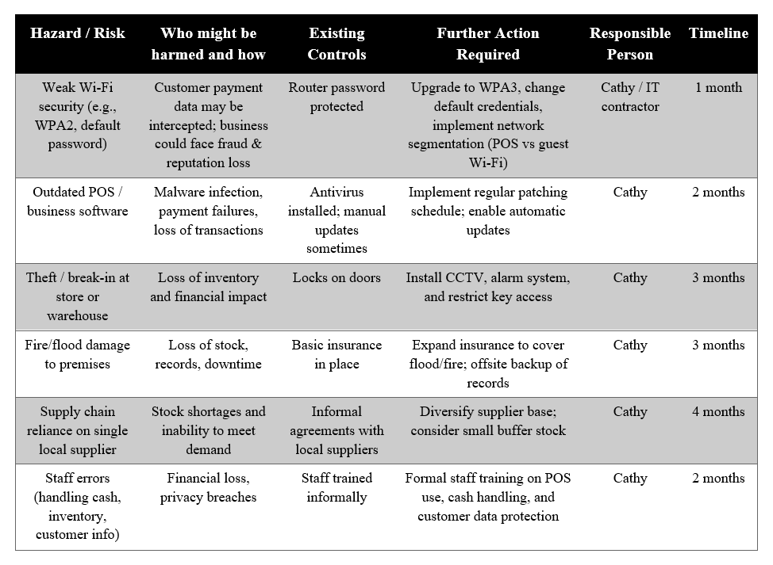

Potential Mitigations
- Technical Controls – Upgrade to WPA3 Wi-Fi, segregate POS network, enable firewalls, maintain automatic software updates
- Physical Controls – CCTV, burglar alarms, fire extinguishers, secured stock areas
- Operational Controls – Staff training, inventory management system, documented supplier contracts
- Strategic Controls – Supplier diversification, insurance review, offsite/cloud record backup

Risk Assessment of Digitalization

Methodology Selection
The ISO/IEC 27005 Risk Management Standard has been selected to assess digitalization risks. This choice is justified because:
- It is specifically designed for information security risk management, directly applicable to e-commerce, ERP, and online operations.
- It aligns with international best practices and compliance standards, which is critical as Pampered Pets begins handling sensitive customer and payment data.
- The methodology is structured yet flexible, making it adaptable for a small business while still demonstrating rigour to stakeholders.
- It supports both qualitative and semi-quantitative assessments, allowing management to understand risks without needing advanced technical expertise.

Proposed Changes
The digital transformation of Pampered Pets is planned around four key initiatives:
- E-commerce Platform – Enables customers to order online, expanding reach beyond local markets
- Enterprise Resource Planning (ERP) System – Centralizes inventory, order processing, and customer data management
- Online Marketing – Builds digital brand presence, drives traffic to the online store, and engages customers
- Partial Transition to International Suppliers – Reduces procurement costs by up to 24%, while maintaining local suppliers as backups

Threat and Risk Modelling

Assets at Risk
- Customer Data – personal and payment information
- Business Systems – e-commerce platform, ERP system
- Brand Reputation – trust is vital in pet care and retail
- Supply Chain – reliability of international partners

Potential Entry Points
- Online storefront (customer-facing)
- Payment gateway
- ERP system (accessible by staff, possibly cloud-based)
- Social media accounts
- Supplier portals and communication channels

Key Threats & Risks
- Cyberattacks such as data breaches or denial of service
- ERP misconfiguration leading to errors in stock or order tracking
- Website usability failures that discourage customers
- Supplier quality issues or delays from overseas vendors
- Phishing/social engineering targeting staff managing new systems
- Regulatory non-compliance (e.g., GDPR, payment security rules)

Risk Assessment Table

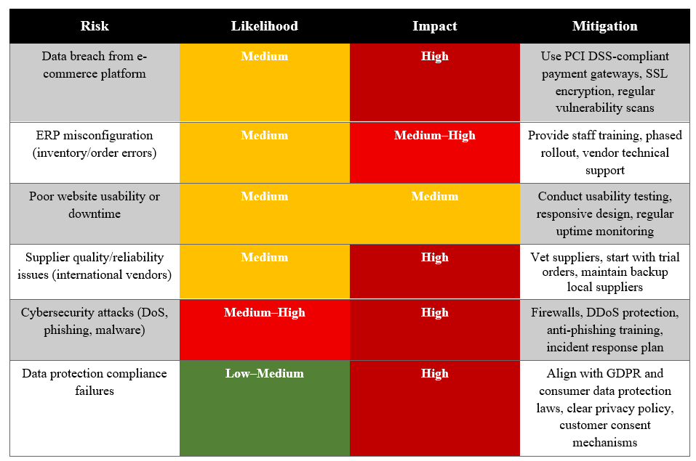

Mitigations
- Technical Controls – Implement PCI DSS-compliant payment gateways, enable SSL/TLS encryption, conduct regular penetration testing, configure ERP with role-based access, enforce multi-factor authentication (MFA) for staff
- Operational Controls – Provide staff training on ERP usage and cybersecurity awareness, establish incident response procedures for system failures or cyberattacks, ensure supplier due diligence and written contractual agreements, schedule routine system audits
- Strategic Controls – Maintain a hybrid supply chain (international and local suppliers), prioritise customer trust with transparent policies and visible security measures (e.g., secure checkout badges), invest in scalable digital platforms to support future growth

Comparative Analysis
Criteria | Status Quo | Digitalization
Customer Base | Risk losing up to 33% without the online features. | 50% growth potential with an online presence.
Costs | Stable and no savings. | The global suppliers can reduce the cost by 24%, but the problem lies in the risk and the quality.
Operations | Manual, limited scalability. | While automated and scalable, this system requires training and investment to implement effectively.
Cybersecurity | Low exposure but weak controls. | There is greater exposure, but this needs to be tackled with effective security practices.
Reputation | Local and traditional | Modern, professional, and competitive in a wider market.

Recommendations
Pampered Pets needs to work on digitalization facilitated by the investments of Orla O’Dour. There is a balance between the benefits (50% business growth, modernization, operational efficiency, and possible cost savings) and the risk, as long as strong risk mitigations are undertaken. The danger of maintaining the status quo is that it will lead to significant losses of customers and stagnation (Chaffey & Ellis-Chadwick, 2019).
Implementation Plan (Phased)
Phase 1 (0–3 months):
- Secure IT infrastructure (network upgrade, firewalls, endpoint protection).
- Staff cybersecurity training.
- Establish a social media presence to enhance online visibility.
Phase 2 (3–6 months):
- Launch an e-commerce portal that would have a secure payment system.
- Add click-and-collect and delivery.
- Start ERP rollout in inventory and track sales.
Phase 3 (6–12 months):
- Explore international suppliers with pilot orders while retaining the local supply chain for quality.
- Expand marketing campaigns to target national customers.
Phase 4 (12+ months):
- Full ERP integration.
- Ongoing monitoring, risk reviews, and system optimization.

4.3. Timeline

Conclusion
The status quo offers short-term stability but risks long-term decline through customer loss and limited growth.
Digitalisation carries higher immediate risks, yet these are manageable with measures such as GDPR compliance, PCI DSS payments, and hybrid supplier strategies. Backed by investment, it also enables growth and resilience.
Pampered Pets should therefore adopt a phased digitalisation strategy to balance innovation with risk control while protecting its reputation.

References
[1] Ajagbe, S. A., Awotunde, J. B., Opadotun, A. T., & Adigun, M. O. (2023) ‘Cybersecurity in the supply chain and logistics industry: A concept-centric review’, in Advances in IoT and Security with Computational Intelligence, Lecture Notes in Networks and Systems, 755, pp. 39–50. Springer.
[2] Chaffey, D., & Ellis-Chadwick, F. (2019). Digital marketing. Pearson UK.
International Organization for Standardization. (2018). ISO 31000:2018 Risk management—Guidelines. ISO. https://www.iso.org/standard/65694.html
[3] Jazairy, A., Brho, M., Manuj, I., & Goldsby, T. J. (2024) ‘Cyber risk management strategies and integration: Toward supply chain cyber resilience and robustness’, International Journal of Physical Distribution & Logistics Management, 54(11), pp. 1–29.

[4] Reddy, R. P. (2025) ‘Understanding cybersecurity risks in supply chain management’, International Journal of Computer Trends and Technology, 73(6), pp. 34–41.

[5] National Institute of Standards and Technology (2021) NIST Special Publication 800-30 Revision 1: Guide for Conducting Risk Assessments. Gaithersburg, MD: NIST.

[6] International Organization for Standardization (2022) ISO/IEC 27005:2022 – Information security, cybersecurity and privacy protection — Guidance on managing information security risks. Geneva: ISO.

[7] Rehman, M. H. ur, Salah, K., Damiani, E., & Svetinovic, D. (2021) ‘Trust and risk management in digital business ecosystems’, IEEE Transactions on Engineering Management, 68(3), pp. 845–857.

